

UNDERGRADUATE PROJECT PROGRESS REPORT

|  |  |
| --- | --- |
| **Project Title:** | **Classroom Reservation Management System** |
| **Surname:** | **Chen** |
| **First Name:** | **Hanly** |
| **Student Number:** | **201918020224** |
| **Supervisor Name:** | **Albert Xu** |
| **Module Code:** | **CHC 6096** |
| **Module Name:** | **Project** |
| **Date Submitted:** | **2023.1.13** |

**Table of Contents**

1 Introduction 3

1.1 Background 3

1.2 Aim 4

1.3 Objectives 4

1.4 Project Overview 4

1.4.1 Scope 4

1.4.2 Audience 5

2 Background Review 5

3 Project Technical Progress 8

3.1 Methodology 8

3.1.1 Approach 8

3.1.2 Technology 12

3.2 Testing and Evaluation 12

3.3 Design and Implementation 13

4 Project Management 18

4.1 Activities 18

4.2 Schedule 20

4.3 Project Version Management 21

4.4 Project Data Management 22

4.5 Project Deliverables 22

5 Professional Issues and Risk: 23

5.1 Risk Analysis 23

5.2 Professional Issues 24

6 References 25

# Introduction

## Background

The electronic information society has become increasingly prevalent, with many colleges and universities transitioning from paper management to electronic information management. (Resmark, 2020) However, many online classroom reservation systems currently available are found to be overly complex and lacking in user-friendly interface. This can create difficulties for both students who are required to submit attendance records and teacher administrators who need access to student data. (Creatrix, 2022) In order to address these issues, this project aims to design and implement a better classroom reservation management system based on the Spring Application Framework, using the Sprint model. The system will feature a report function and dynamic data display to allow for more efficient and concise management of university classroom information. (Programmerall, 2022)

The system will be user-friendly and easy to navigate, with a simple interface that allows students and teacher administrators to quickly and easily reserve or manage classrooms. (Merriam, 2022)The system will also include features such as teacher administrator management and student reservation functions, which will allow teacher administrators to manage their own classrooms and student to quickly and easily book a classroom for their next class. Additionally, the system will include a reporting function that will allow teacher administrators and administrators to easily view and analyze data on classroom usage and occupancy.

Furthermore, the system will be designed to be highly customizable, allowing universities to easily tailor it to their specific needs. This will include options for different reservation protocols and policies, as well as the ability to integrate with other existing systems and technologies. (Programmerall, 2022) With this new system, universities will be able to streamline their classroom reservation process and improve the overall efficiency of their operations.

In conclusion, this project aims to design and implement a better classroom reservation management system based on the Spring Application Framework, using the Sprint model. The system will be user-friendly and easy to navigate, with a simple interface that allows students and teacher administrators to quickly and easily reserve or manage classrooms. It will also include features such as teacher administrator management and student reservation functions, which will allow teacher administrators to manage their own classrooms and student to quickly and easily book a classroom for their next class.

## Aim

To design and implement a better classroom reservation management system that aims to assist teacher administrators and students in managing and scheduling class reservations more efficiently.

## Objectives

The objectives of the system are as follows:

1. completes the background review of the existing classroom reservation management system.

2. divides clear functions according to roles to facilitate data management.

3. has developed the teacher administrator management function to display the user's usage in real time.

4. develops the function of students' classroom reservation, which can dynamically display relevant data of the system.

5. demonstrates the works to mixed audiences.

## Project Overview

### Scope

The scope of this project is to design and implement a classroom reservation management system. The system will allow teacher administrators to login and manage classroom information, review student's appointment applications, and view past appointment records. It will also allow students to login, view classroom information, make appointments, and modify their personal information. The system will be developed using Java, JSP, SSM, and B/S architecture and will utilize a MySQL database. The significance of this project lies in its ability to improve the current classroom reservation process by providing a more efficient and user-friendly system for both teacher administrators and students. It aims to improve the communication and information exchange between them.

### Audience

The primary audience for this project is university teacher administrators and students. teacher administrators will benefit from the system's administrator login function, which allows them to access the classroom reservation management system and manage classroom details, review student appointment applications, view past appointment records, and register their own and students' accounts. Students will benefit from the system's user login function, which allows them to view classroom details, view their past appointment records, make classroom reservations, and modify their personal information. Additionally, this system will also be useful for administrators and staff members who are responsible for managing the classrooms and appointments at the university level. Overall, the goal is to improve the efficiency and ease of managing classroom reservations for all stakeholders involved.

# Background Review

The background review for this classroom reservation management system project aims to summarize existing approaches in the field, specifically focusing on the software development methodologies and systems that have been previously employed.

According to Ralph (2021), the traditional approach for teacher administrator appointment systems has been to use the waterfall model for development, which emphasizes cooperation and exporting results to various formats for storage. However, this approach can lead to an irreversible development process, with high costs and difficulty in meeting all user requirements, resulting in complex data and difficult user operations.

Additionally, existing systems on the market, such as Skedda (2022), have the capability to arrange students' schedules. However, these systems tend to have complex pages and not simple and efficient enough operation pages.(Bagyatech,2020) In contrast, the proposed classroom reservation management system aims to develop a report function that can dynamically display relevant data, and employs innovative functional methods in order to optimize the current systems on the market. By making the pages simple and beautiful and the operation pages simple and efficient, the system aims to better cater to the needs of students and busy teacher administrators and improve its competitiveness in the field.  
To further understand the current state of the market, a comparison of popular classroom reservation management systems, such as Microsoft Bookings, Doodle, Calendly, TimeCenter, and Acuity Scheduling, was conducted. A table was created to compare the strengths and weaknesses of each system in terms of their application and technology. This analysis revealed that while each system had its own unique features and capabilities, there was still room for improvement in terms of user-friendliness and efficient data management. In light of these findings, the proposed classroom reservation management system aims to address these issues and provide a more user-friendly and efficient solution for teacher administrators and students.

| **Logo** | **System** | **Strengths** | **Weaknesses** |
| --- | --- | --- | --- |
|  | Microsoft Bookings | 1.Integration with Office 365 and Outlook calendar.  2.Customizable booking forms and confirmation emails.  3. Ability to set up recurring appointments. | 1. Limited customization options for the user interface.  2. Limited reporting and data analysis capabilities. |
|  | Doodle | 1.Easy to use and navigate.  2.Ability to create polls for scheduling meetings.  3.Integration with Google Calendar and Outlook.  4. Advanced scheduling options such as buffer times and group events. | 1. Limited customization options for the user interface.  2. Limited integration with other systems. |
|  | Calendly | 1.Easy to use and navigate.  2. Customizable booking forms and confirmation emails.  3. Ability to set up recurring appointments.  4. Advanced reporting and analytics capabilities. | 1. Limited reporting and data analysis capabilities.  2. There is not enough report generation capability to keep abreast of classroom usage. |
|  | TimeCenter | 2.Easy to use and navigate.  2.Customizable booking forms and confirmation emails.  3. Ability to set up recurring appointments. | 1. Limited customization options for the user interface.  2. There is not enough report generation capability to keep abreast of classroom usage. |
|  | Acuity Scheduling | 1.Customizable booking forms and confirmation emails.  2.Ability to set up recurring appointments.  3.Integration with other systems such as Zapier and Stripe.  4. Advanced scheduling options such as appointment types and staff availability. | 1. Limited customization options for the user interface.  2. Limited integration with other systems. |

Table 1: Comparison table of market CRMS

# Project Technical Progress

## Methodology

### Approach

The approach for this software development project will be based on the Spring Application Framework (SAF) and the Agile software development methodology. The SAF is a popular Java framework used for building enterprise applications. It provides a comprehensive set of features for web and enterprise applications and allows for the use of common design patterns such as Model-View-Controller (MVC) and Inversion of Control (IoC). The Agile methodology will be used to manage and organize the development process, ensuring that the project is delivered in a timely and efficient manner.The following is the MVC framework structure and technical roadmap of this project:

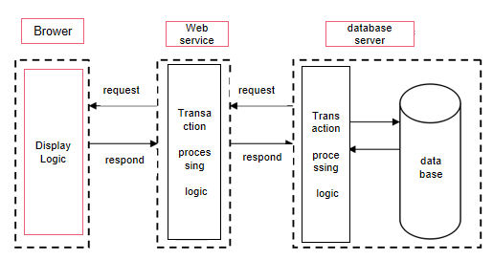

Figure1. MVC Frame Structure of the Third Floor

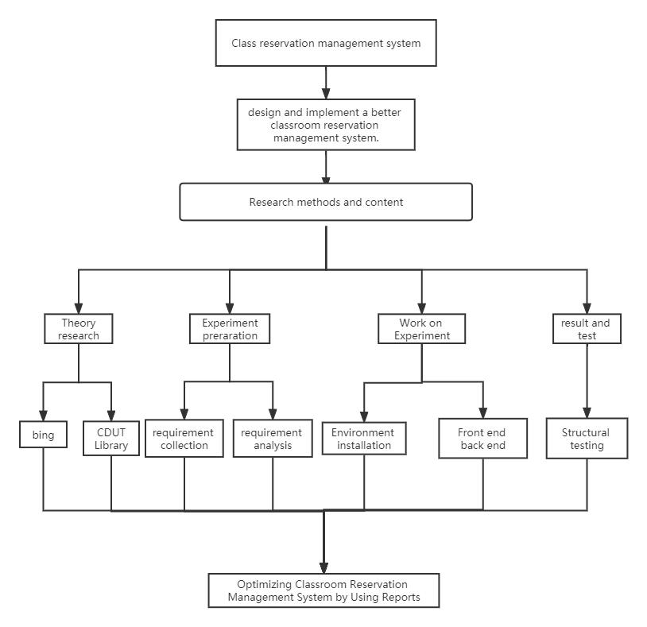

Figure2. Technical Roadmap

1. Development Model

The project will utilize a sprint-based development model, which is a popular Agile methodology used in software development. This model involves breaking the project down into smaller, manageable chunks called sprints, each of which lasts about one week for a total of 16 weeks in duration. Each sprint includes a planning phase, development phase, testing phase, and review phase. By breaking the project into smaller chunks, the team can better manage the scope and timelines of the project, as well as make adjustments as needed.The following is the sprint development model diagram:

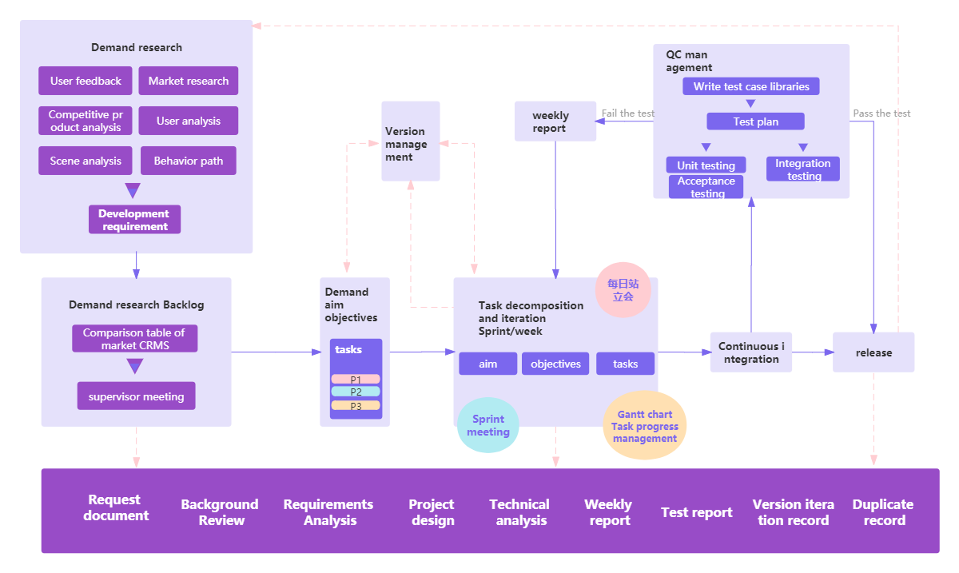

Figure3. sprint development model diagram

1. Requirements Analysis

The project will begin with a thorough requirements analysis, which will involve gathering information about the needs and goals of the users. This will be done through a variety of methods, including interviews, surveys, and workshops. The information gathered will be used to create use case diagrams and a Sequence diagram of user registration, which will outline the functional and non-functional requirements of the system.

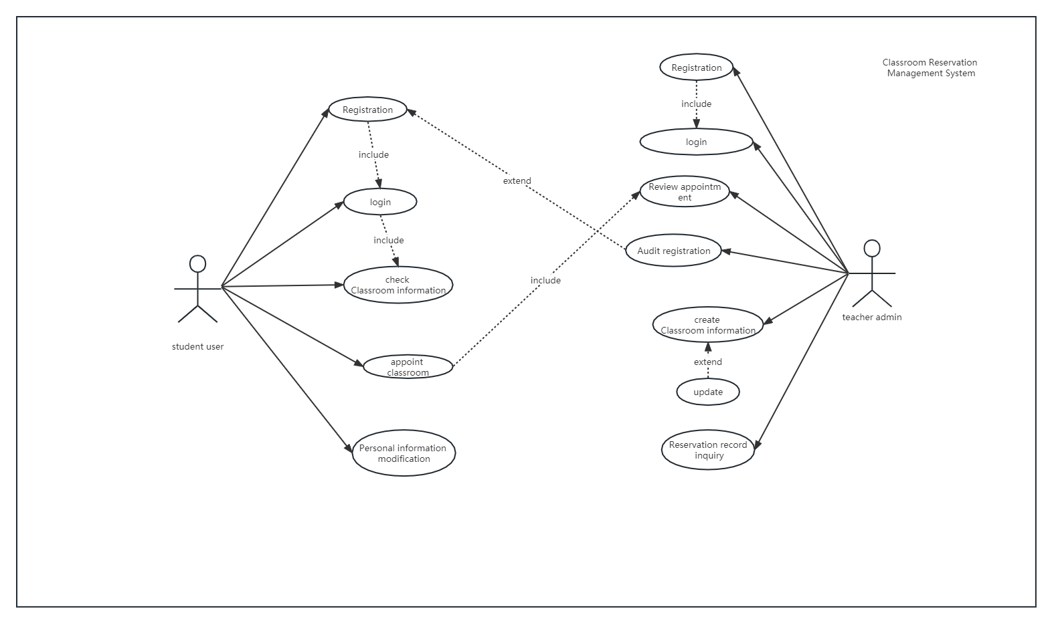

Figure4. CRMS use case diagram

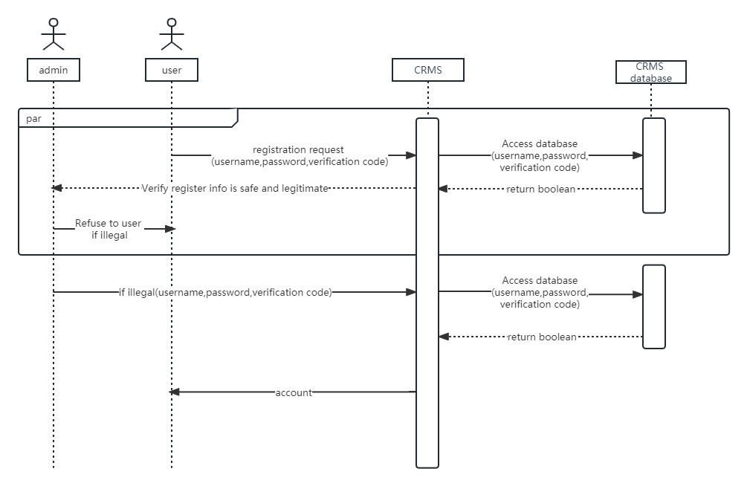

Figure5. CRMS Sequence diagram of user registration

#### Software Development Model

#### demand analysis

### Technology

In order to ensure the accuracy of the experiment, all experiments in this paper use the same platform, using dual video cards, and the memory size reaches 512G. The specific configuration is demonstrated in Table 1 below:

|  |  |
| --- | --- |
| **Configuration** | **Details** |
| Operating system | Windows |
| Development tool | Eclipse |
| Development technology: | Java |
| Database: | MySQL |
| Processor | Core i5 generation 4 series CPU main frequency, 2.7GHz dynamic, acceleration frequency: above 3.6GHz |
| Memory | 8G (or above) |
| Hard disk | 512G solid state disk (or above 512G) |

Table 2 Configuration of Experimental Platform

## Testing and Evaluation

For this classroom reservation management system project, we will be adopting a Test-driven development (TDD) style. Our test and evaluation plan will focus on three different types of software testing techniques: unit testing, integration testing, and acceptance testing.

Unit testing will be used to test individual units of code, such as methods and functions, to ensure that they are working correctly. This will be done using a unit testing framework, such as JUnit, and test cases will be written to cover all possible scenarios and edge cases, including testing the registration process for both teachers and students.

Integration testing will be used to test the integration of different modules and components of the system. (such as student modules, teacher modules, back-end modules) This will involve testing how well the different units of code work together and how they handle different inputs and outputs, including testing the integration of the registration process with the rest of the system. This will also be done using a testing framework and test cases will be written to cover all possible scenarios and edge cases.

Acceptance testing will be used to test the system as a whole and ensure that it meets the requirements and expectations of the users. This will involve testing the system with real users, such as teachers and students, and collecting their feedback. The acceptance testing will also include usability testing to ensure that the system is user-friendly and easy to use, including testing the registration process to ensure its usability.

## Design and Implementation

The proposed classroom reservation management system will be developed using a combination of front-end and back-end technologies. The front-end will be developed using HTML, CSS, and JavaScript, while the back-end will be developed using a combination of Mybaits and MySQL.

The overall design of the system will consist of three main modules: a student module, a teacher module, and a back-end module. The student module will allow students to view available classrooms, make reservations, and view their own reservations. The teacher module will allow teachers to view and manage classroom reservations, as well as view statistics and reports on classroom usage. The back-end module will handle the database and server-side logic, including data validation and security.

The system architecture will be designed using a Model-View-Controller (MVC) pattern, with the database serving as the Model, the front-end as the View, and the back-end as the Controller. This will allow for a clear separation of concerns and easy maintenance and scalability.

The database design will consist of several tables, including a "room" table, a "reservation" table, and a "user" table,and a "role" table. The "room" table will store information about each classroom, including its name, capacity, and available equipment. The "reservation" table will store information about each reservation, including the classroom, date, and time. The "user" table will store information about each user, including their name, email, and role (student or teacher).The "role" table stores information about each role, including the role id and the role name.

Functional screenshots of each module will be provided, including the student module, teacher module, and back-end module. These screenshots will demonstrate the features and functionality of each module, including the ability to view and make reservations, view statistics and reports, and manage user accounts.

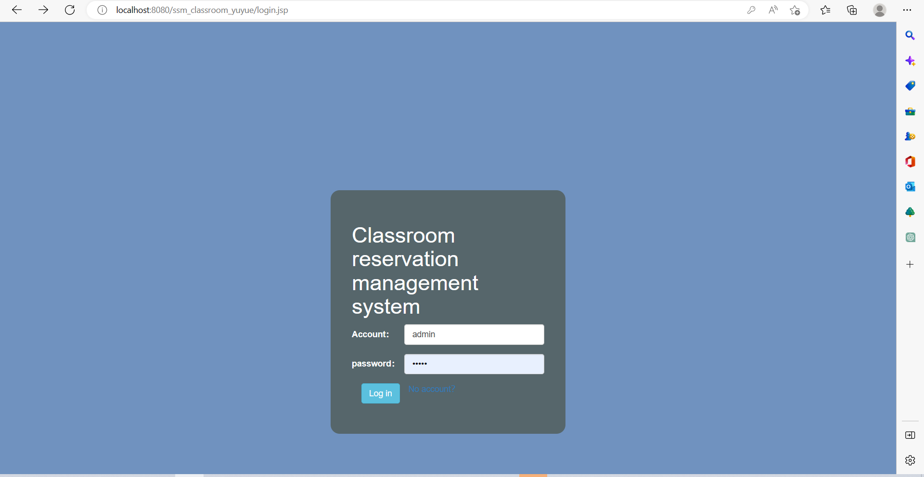

Figure 6. CRMS home and login page

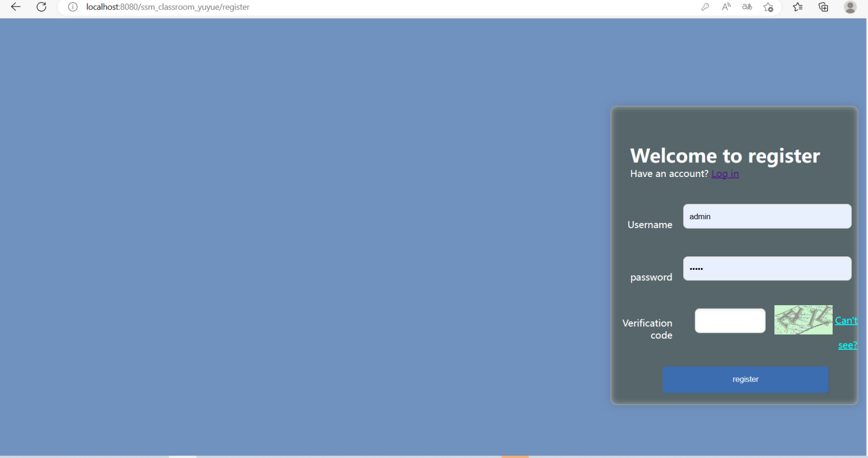

Figure 7. CRMS Registration page

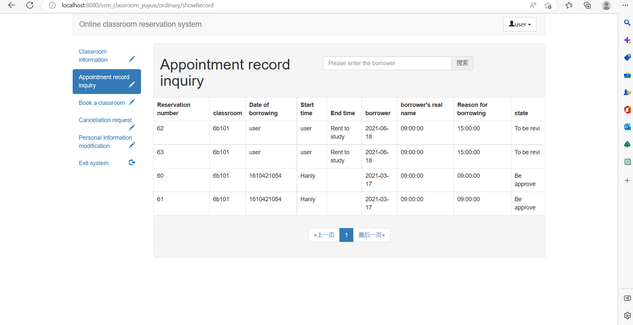

Figure 8. CRMS Student appoint Record page

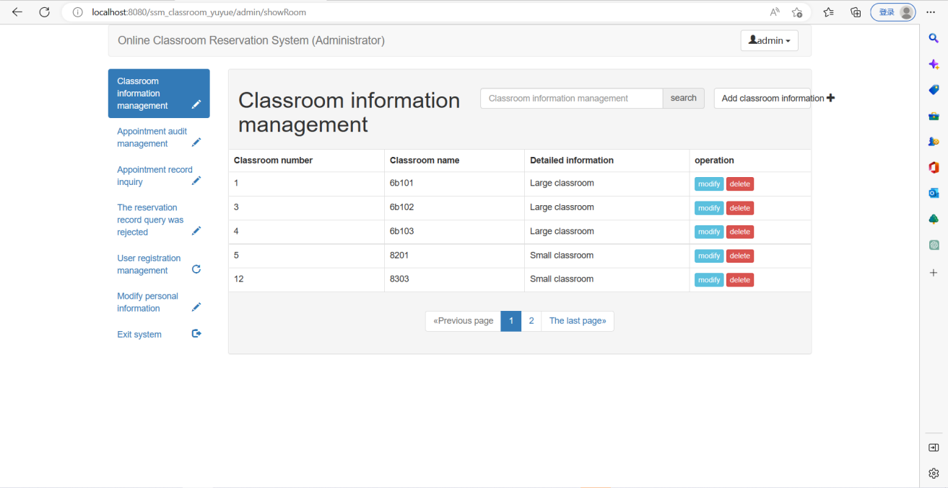

Figure 9. CRMS teacher admin showroom page

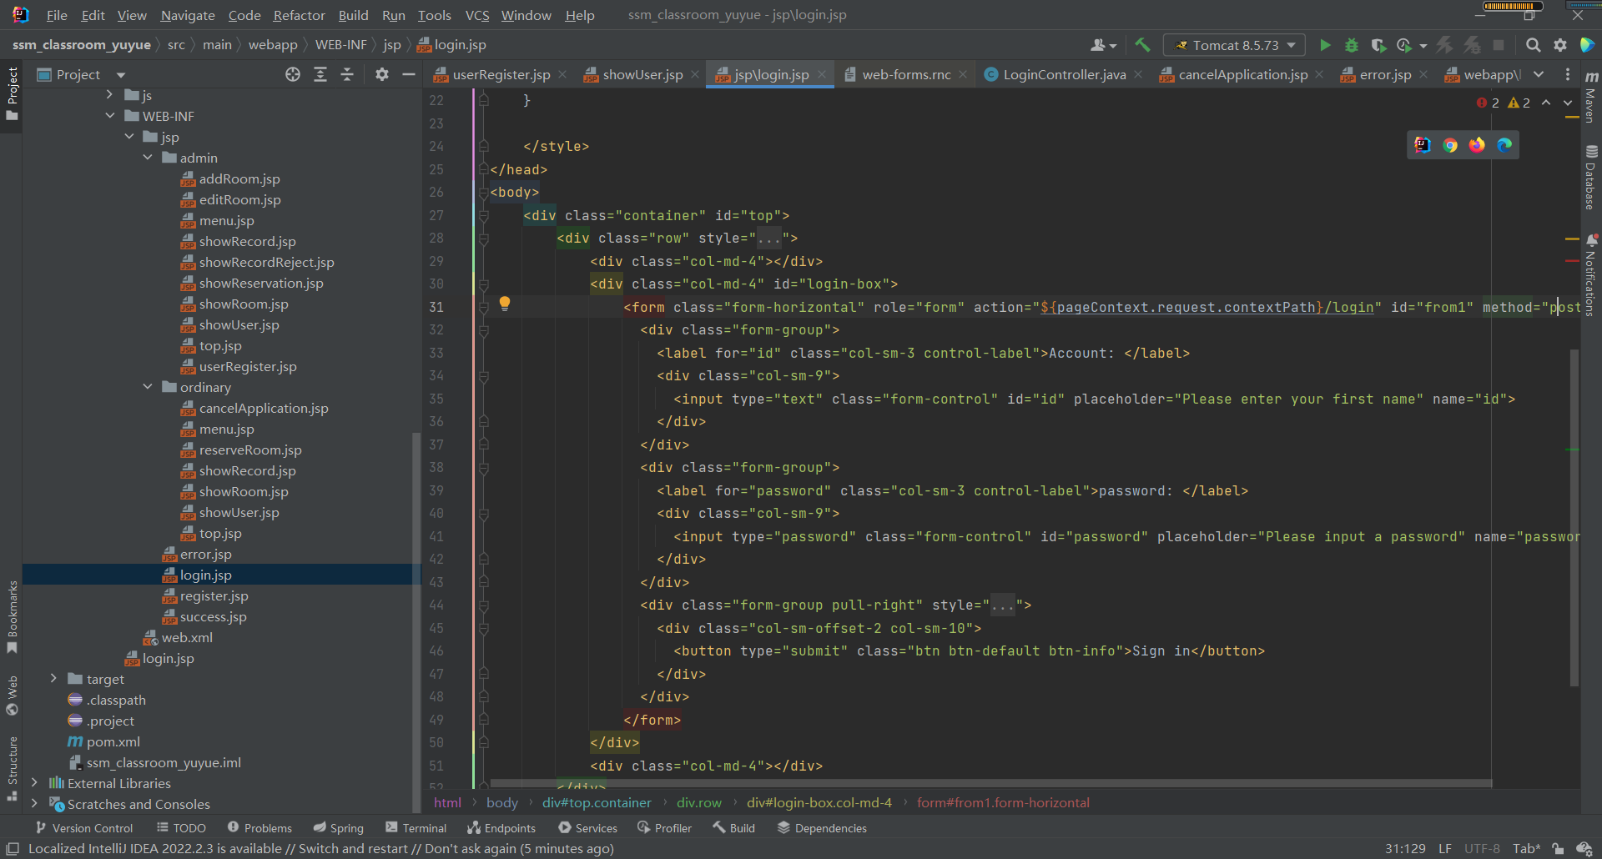

Figure 10. CRMS login front-end code

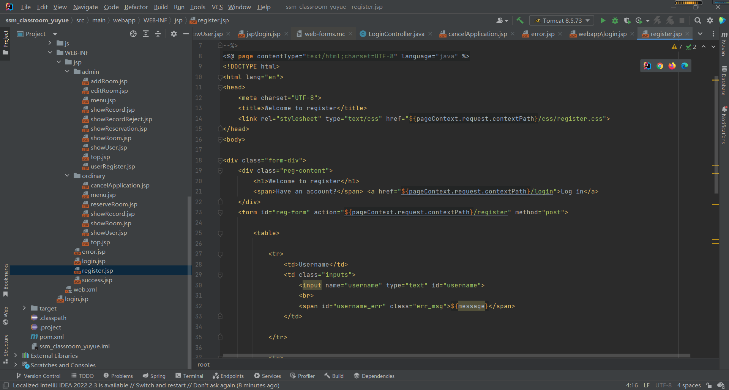

Figure 11. CRMS register front-end code

The code for the database and its connection to the back-end will also be provided, along with diagrams illustrating the relationships between the tables. This will demonstrate the work that has been done to create a functional and efficient system.

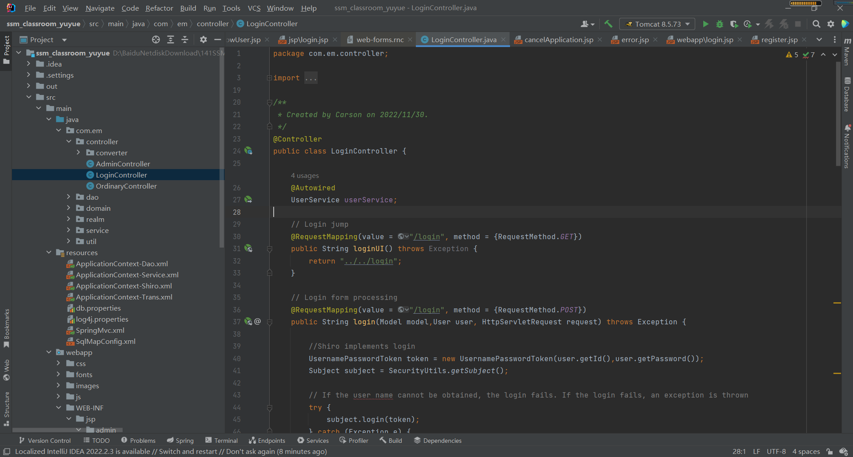

Figure 12. CRMS login back-end link database code

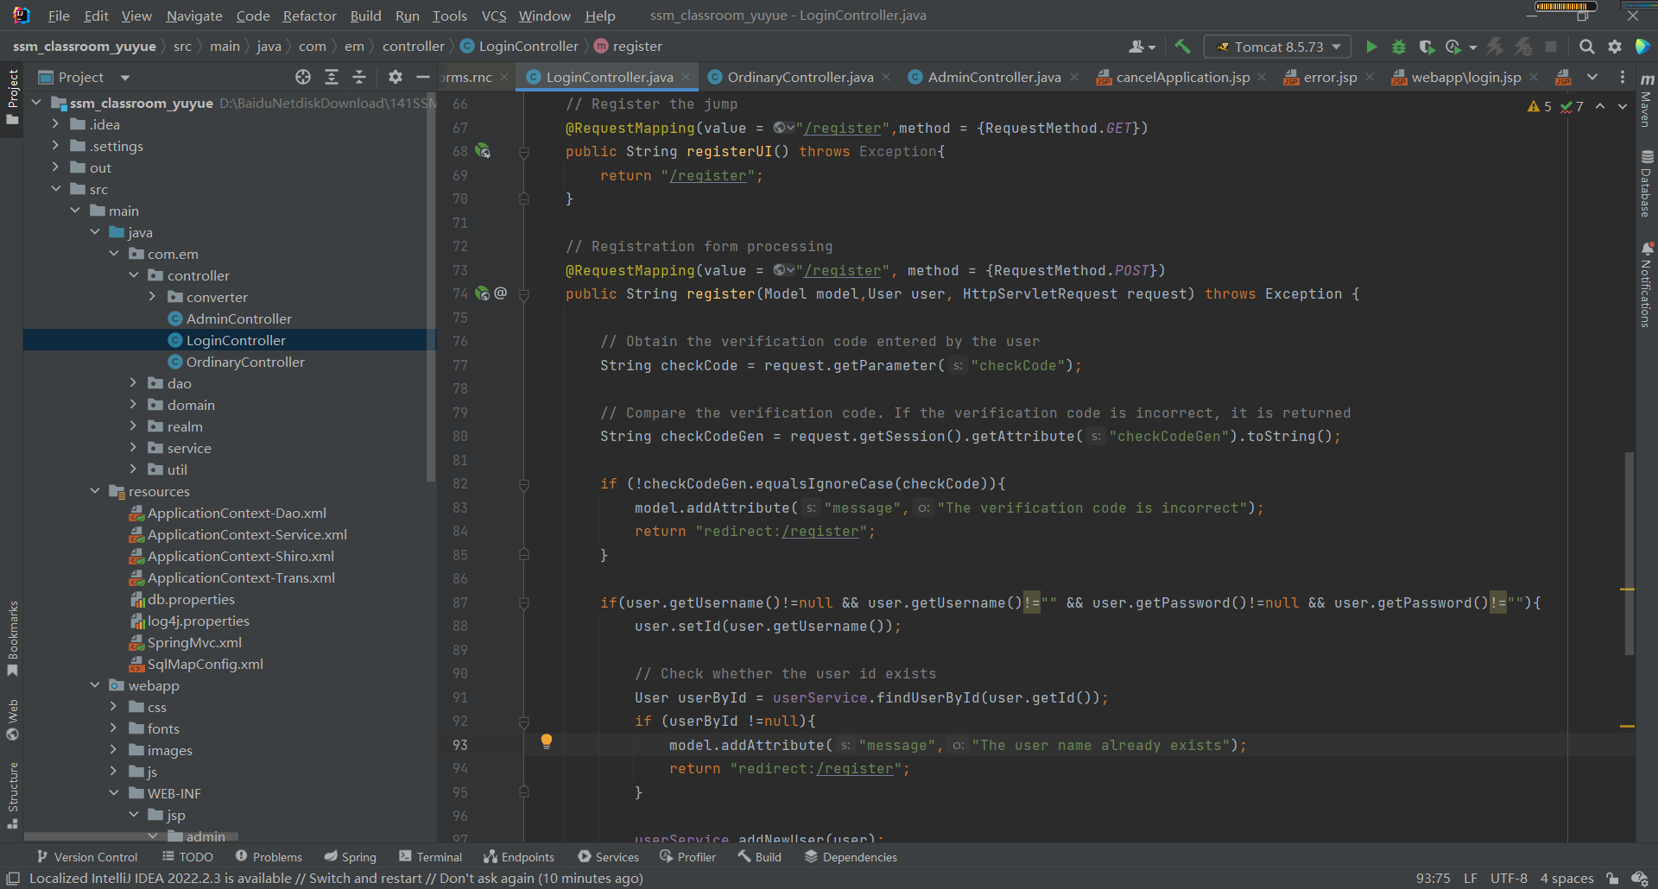

Figure 13. CRMS register back-end link database code

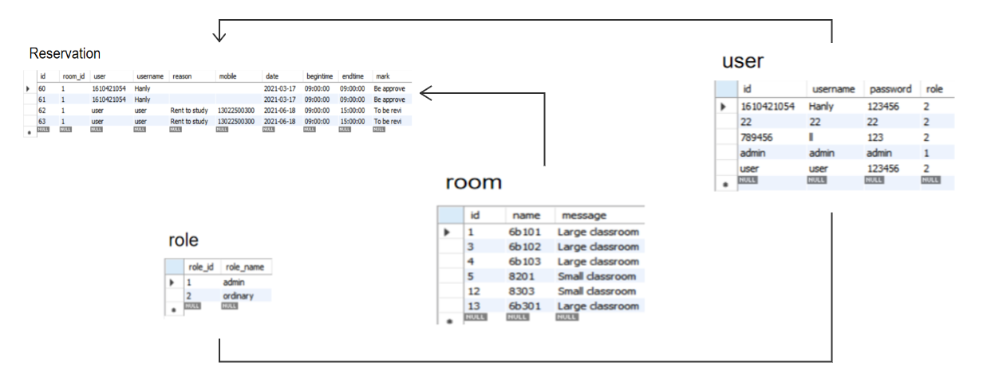

Figure 14. Database ER diagram

# Project Management

## Activities

To achieve the project's overall aim and objectives, several key tasks have been identified. The following is a summary of the completed and uncompleted tasks for each objective:

1. completes the background review of the existing classroom reservation management system.(Deliverables: survey website and results, demand analysis conclusions, analysis of existing models)

1.1 System search for similar software (deadline: 2022.11.7)(completed)

1.2 Create Feature Comparison Table (deadline: 2022.11.9)(completed)

1.3 Complete literature search (deadline: 2022.11.11)(completed)

1.4 Literature review (deadline: 2022.11.13)(completed)

1.5 Conduct user survey (deadline: 2022.11.15)(completed)

1. divides clear functions according to roles to facilitate data management.(Deliverables: role function results, database table, ER diagram, function structure diagram)

2.1 Division of roles(deadline: 2022.11.22)(completed)

2.2 Functional division of the first role(deadline: 2022.11.27)(completed)

2.3 Functional division of the second role(deadline: 2022.12.2)(completed)

2.4 Feasibility analysis of divided functions(deadline: 2022.12.7)(completed)

2.5 Organize role function (deadline: 2022.12.12)(completed)

1. has developed the teacher administrator management function to display the user's usage in real time.(Deliverables: background login code, management function code)

3.1 Design and develop administrator login function (deadline: 2022.12.17)(completed)

3.2 Design and develop classroom information management function (deadline: 2022.12.25)(completed)

3.3 Design and develop registered user functions (deadline: 2022.12.30)(completed)

3.4 Design and develop appointment function (deadline: 2023.1.7)(completed)

3.5 Design and develop appointment audit function (deadline: 2023.1.15)(uncompleted)

1. develops the function of students' classroom reservation, which can dynamically display relevant data of the system.(Deliverables: homepage login code, reservation function code)

4.1 Design and develop user login function (deadline: 2023.3.7)(uncompleted)

4.2 Design and develop classroom information query function (deadline: 2023.3.15)(uncompleted)

4.3 Design and develop reservation record query function (deadline: 2023.3.30)(uncompleted)

4.4 Design and develop the function of reserved classroom (deadline: 2023.4.15)(uncompleted)

4.5 Design and develop personal information modification function (deadline: 2023.4.30)(uncompleted)

1. demonstrates the works to mixed audiences.

5.1 Materials and processes to be displayed (deadline: 2023.5.17)(uncompleted)

5.2 Presentation process to mixed audiences (deadline: 2023.6.4)(uncompleted)

## Schedule

A Gantt chart has been developed to visualize the project schedule and track the progress of tasks. The chart illustrates the timeline of the project, the start and end dates of each task, and the dependencies between tasks. It also highlights the completed and uncompleted tasks, as well as any delays or changes to the original plan.

The Gantt chart for the Classroom Reservation Management System project is shown in Figure 1 below:

It shows that the majority of the research and design tasks have been completed, including the background review, system design, and database design. The implementation tasks, such as the development of the teacher administrator management function and the student reservation function, are currently in progress.

It is important to note that this Gantt chart is not the final version, it will be updated as the project progresses.

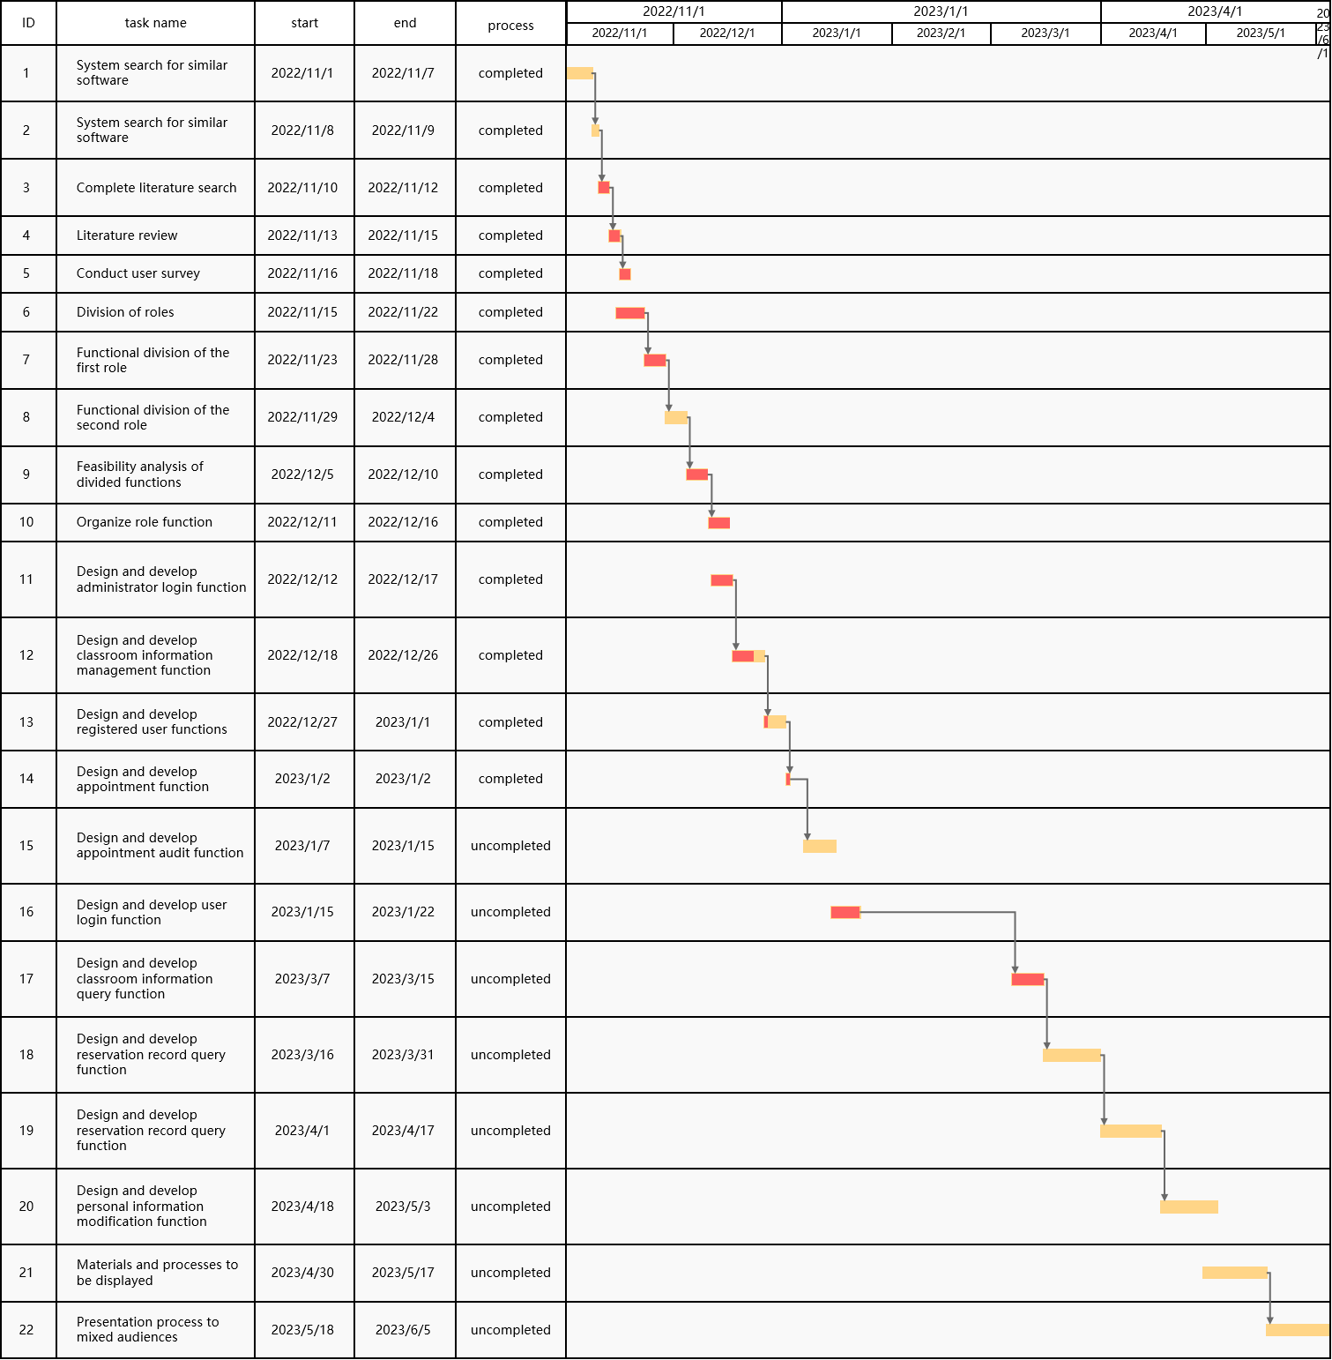

Figure 15. Gantt chart of the Classroom Reservation Management System project

## Project Version Management

In order to effectively manage the project source codes, a version management plan was implemented using Baidu drive. This platform was chosen as it is secure, user-friendly and allows easy access to project files. A dedicated folder was created to store all project source codes, and all changes were tracked and recorded in the version management system. Additionally, regular backups were made to ensure that all important files were secure in case of any issues or errors.

This approach also allowed for efficient collaboration between the project developer and supervisor, as all files were easily accessible and changes were clearly recorded. This ensured that the project development process was transparent, and that any problems could be identified and resolved promptly. This version management plan allowed for an organized, efficient, and streamlined development process throughout the project lifecycle.

## Project Data Management

The project data management for this project is mainly done through the use of Baidu drive. This is an online storage platform that allows for the storage and sharing of project related documents such as logs, reports, and literature. The platform is secure and can only be accessed by the author and the supervisor. This ensures that the data is kept confidential and is only accessible to those who need it.

In terms of organization, all project-related documents are stored in a dedicated folder on Baidu drive. This includes project logs, reports, and literature, among others. These documents are organized in a logical and easy to navigate manner, making it easy to find the relevant information when needed. The platform also allows for easy sharing of documents with the supervisor, which is essential in facilitating the review and feedback process. Overall, Baidu drive serves as an efficient and secure tool for managing the project data.

## Project Deliverables

In this section, the project deliverables that have been submitted or are yet to be submitted for assessment are outlined. These include the project proposal, progress report, final report, and any relevant project code or software developed throughout the course of the project. Additionally, any additional resources or documents that have been created as part of the project, such as documentation for user manual, system architecture, are also included in the list of deliverables. The goal of this section is to provide a clear and concise overview of all the materials that have been created and submitted as part of the Classroom Reservation Management System project. It's important to mention the accessibility to those deliverables, such as the project code and software is only accessible by the supervisor and the author.

# Professional Issues and Risk:

## Risk Analysis

In this section, an analysis of the risks associated with the Classroom Reservation Management System project is presented. The table below shows the potential risks identified, their causes, the severity and likelihood of the risks, and the mitigation strategies implemented to address them.

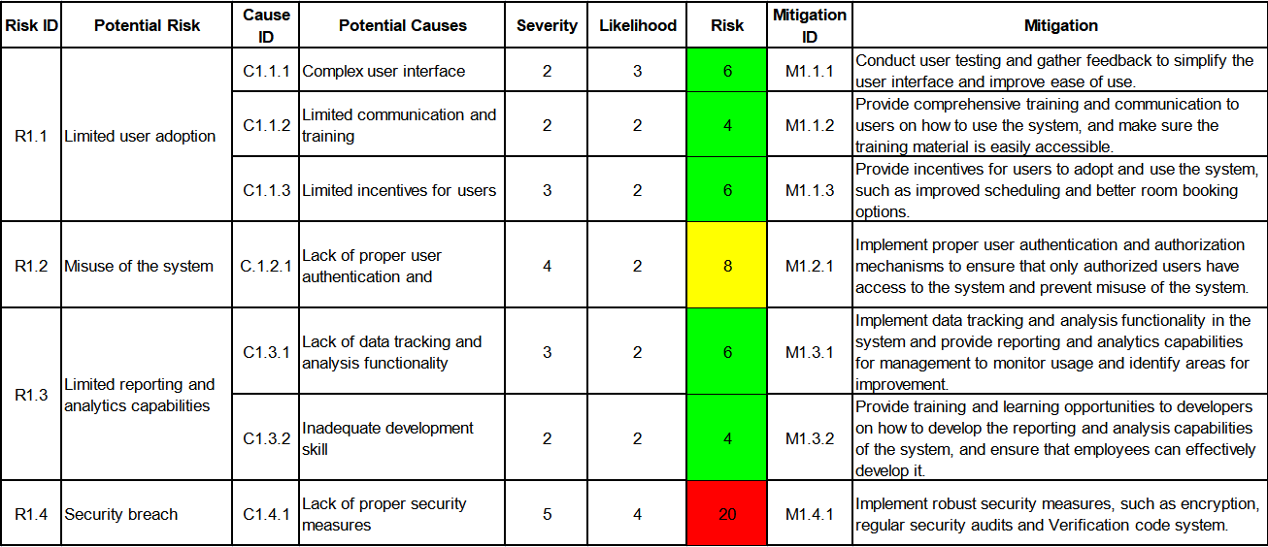

Figure16. software development risks

As seen in the table, all identified risks were mitigated successfully with the actions taken, and at this point, the project is on track to meet its deadlines with all the core features having been completed and the user login and classroom reservation functionalities being fully operational and also having implemented a robust database system.

## Professional Issues

In the background of the Classroom Reservation Management System project, there are several professional issues that must be considered. One of the main legal issues is data protection and privacy. The system stores and processes personal information, such as student names and ID numbers, as well as reservation information. It is important to ensure that this information is stored securely and only accessible to authorized individuals. To address this issue, the system must comply with relevant data protection laws, such as the General Data Protection Regulation (GDPR). Additionally, it should have a clear privacy policy that outlines how the data will be used and protected.

Another professional issue to consider is accessibility. The system must be designed to be accessible to all students, regardless of their physical or cognitive abilities. This includes ensuring that the system is compatible with assistive technology and that the user interface is intuitive and easy to navigate.

In terms of social and ethical issues, it is important to ensure that the system is fair and unbiased. This includes ensuring that the reservation process is transparent and that reservations are allocated in a fair and impartial manner. Additionally, it should also consider any potential impact on the environment from the system, such as any energy consumption.

Lastly, the development of the system must adhere to relevant professional codes of conduct, such as those set by the British Computer Society (BCS) and the Association for Computing Machinery (ACM). These codes outline professional standards and ethical principles for the development and use of technology.

# References

Resmark (2020) Why a reservation management system is important, Resmark. Available at: https://www.resmarksystems.com/blog/why-a-reservation-management-system-is-important (Accessed: November 9, 2022).

Creatrix (2022) Online classroom management software system, Creatrix Campus. Available at: https://www.creatrixcampus.com/classroom-management-system (Accessed: November 9, 2022).

Skedda (2022) Classroom scheduling software - venue management, Skedda. Available at: https://www.skedda.com/home/classroom-scheduling-software (Accessed: November 9, 2022).

programmerall (2022) Part I. spring boot documentation, Spring Boot Chinese document (Official document translation based on 1.5.2.RELEASE) - Programmer All. Available at: https://www.programmerall.com/article/8331715216/ (Accessed: November 13, 2022).

Merriam (2022) System definition & meaning, Merriam-Webster. Merriam-Webster. Available at: (Accessed: November 9, 2022).

Adriano, R. (2021) Classroom reservation system, Creately. Available at: https://creately.com/diagram/example/hqrksio41/classroom-reservation-system (Accessed: November 14, 2022).

Bagyatech (2020) Advantages of waterfall model and its disadvantages, Bagyatech. Available at: https://bagyatech.com/advantage-and-disadvantage-of-waterfall-model/#:~:text=The%20notable%20advantages%20%26%20disadvantages%20of%20the%20Waterfall,work%20on%20the%20project%20and%20never%20feels%20bored. (Accessed: November 14, 2022).